Assignment 1:

Task1:

1.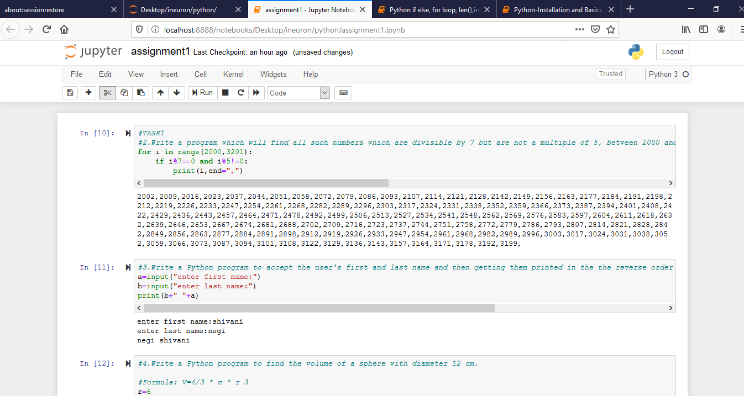

2. for i in range(2000,3201):

if i%7==0 and i%5!=0:

print(i,end=",")

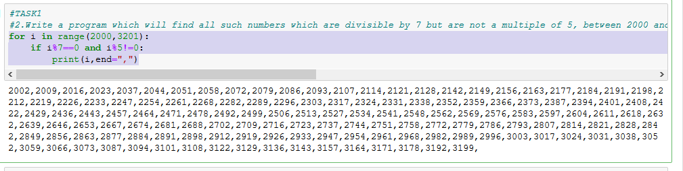

3. a=input("enter first name:")

b=input("enter last name:")

print(b+" "+a)

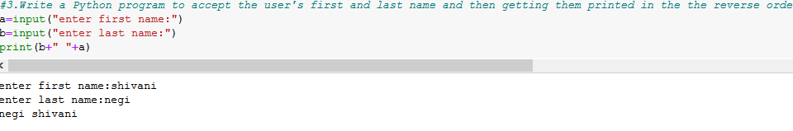

4. r=6

pi=3.14

v=(4/3)\*pi\*(r\*r\*r)

v

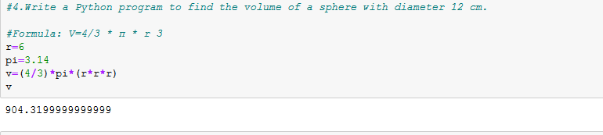

TASK2:

1. input("enter number").split(",")

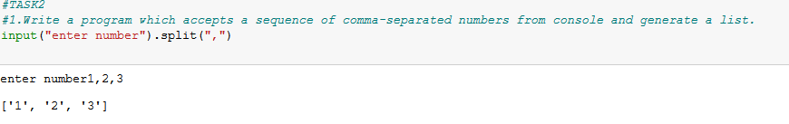

2. for i in range(0,5):

for j in range(0,i+1):

print("\*",end="")

print("")

for k in range(5,9):

c=9-k

for l in range(0,c):

print("\*",end="")

print("")

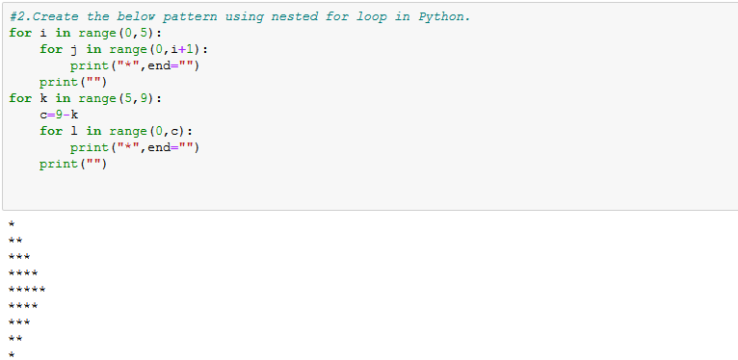

3. a=input("enter word:")

print(a[::-1])

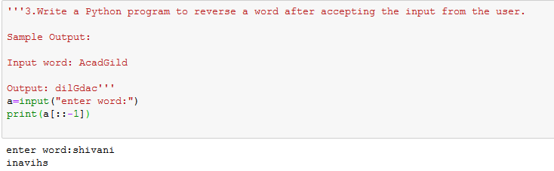

4. a='''WE, THE PEOPLE OF INDIA,

having solemnly resolved to constitute India into a SOVEREIGN,

SOCIALIST, SECULAR, DEMOCRATIC REPUBLIC

and to secure to all its citizens '''

print(a)

